Biology, Castle View High School  
Jason R Mayberry, PhD

**Study Guide: Lipids and Carbohydrates**

**Vocabulary**

1. Lipid
2. Triglyceride
3. Phospholipid
4. Steroids
5. Cholesterol
6. Amphipathic
7. Phospholipid Bilayer
8. Organic Soup (also called Primordial Soup)
9. Protocell
10. Carbohydrates
11. Monosaccharide
12. Disaccharide
13. Polysaccharide
14. Glycogen
15. Starch
16. Cellulose
17. Photosynthesis
18. Cellular Respiration
19. Glycoprotein
20. Glycolipid

**Conceptual Questions**

1. Draw the basic/simplified structure of a **triglyceride**? What is made of triglycerides?
2. Draw the basic/simplified structure of a **phospholipid**. What is made of phospholipids?
3. Be able to recognize a **cholesterol** molecule (or any of its steroid derivatives such as testosterone and estrogen).

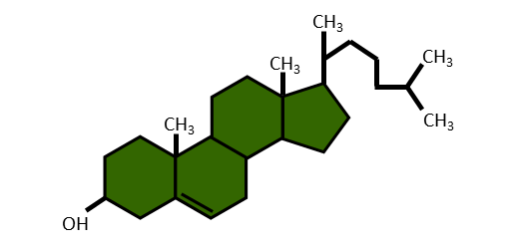

1. Describe how the properties of a phospholipid make it good for forming membranes.

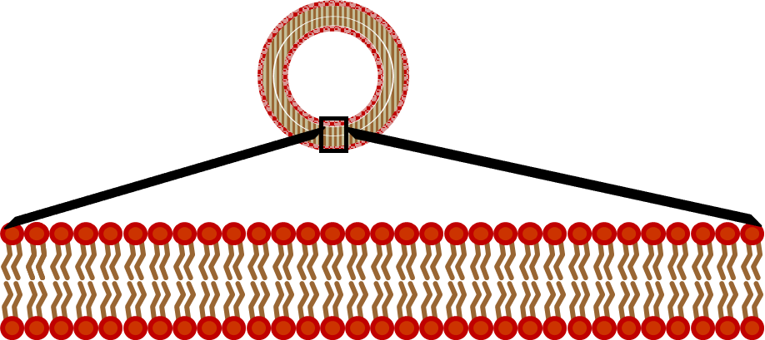

1. Describe the structure and composition of cellular membranes.

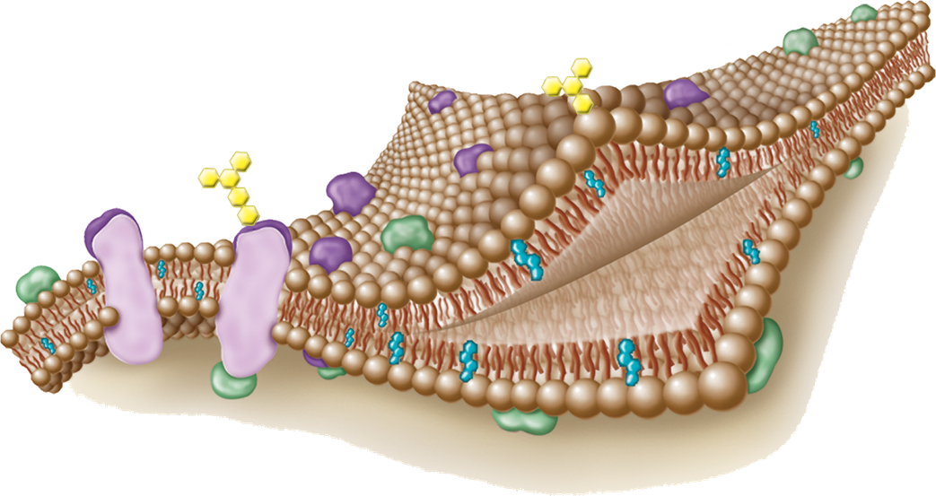

1. How did the first cells form out of the Organic Soup (also called Primordial Soup)?

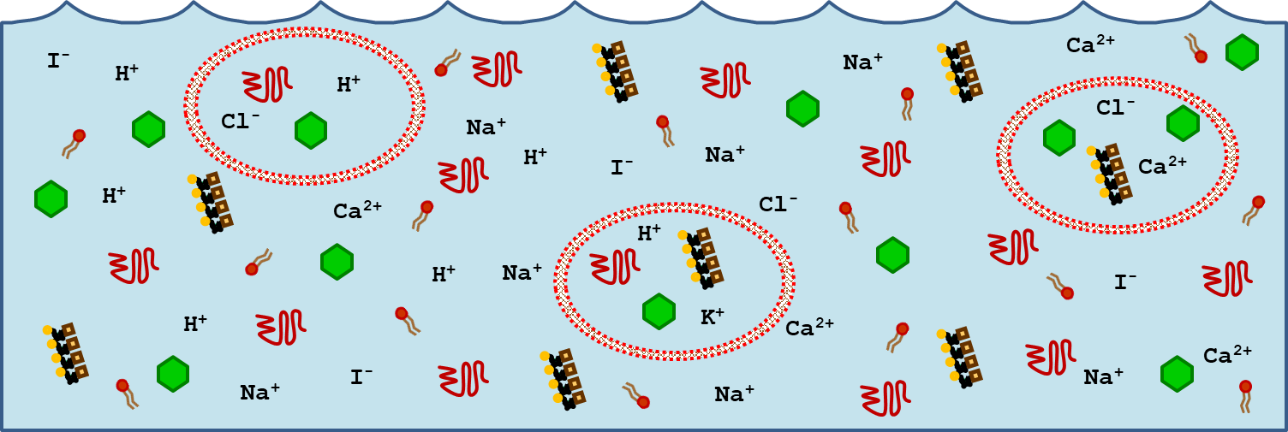

1. Give examples of the processes that arose from the interactions of organic molecules captured in the first protocells.
2. Describe why the term “Carbohydrate” is an appropriate term to describe the molecules given this name.
3. Draw a **monosaccharide**. What feature gives this away as a carbohydrate?
4. Draw a simplified **Disaccharide**
5. Draw a simplified polysaccharide.
6. Contrast the uses of Glycogen, Starch, and Cellulose.
7. ***Briefly*** describe how carbohydrates are made.
8. ***Briefly*** describe some key uses of carbohydrates.

